When you assign the value of one data type to another, it is called type casting.

In Java there are two types of type casting:

* Up Casting (or widening)  
  Converting a smaller type to larger type. It is done automatically.
* Down Casting (or narrowing)  
  Converting a larger type to a smaller type. It explicitly needs to be specified.

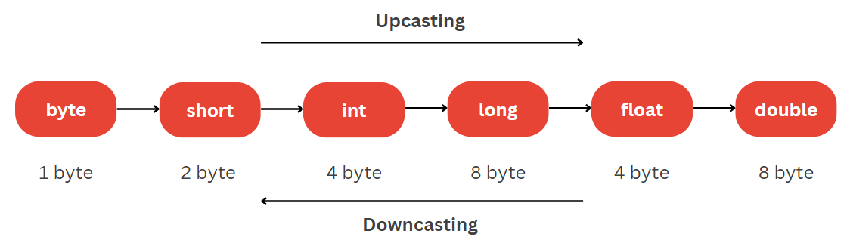

Example:

